17 Jul Made in America: LondonTown USA
POSTED AT 09:03H IN MADE IN AMERICA SERIES, NEWS BY 2NDVOTE MARKETING
Here at 2ndVote, we always advocate for the three pillars of shopping your values; Shop Local whenever possible, Shop the Highest 2ndVote Score whenever possible, and Shop American whenever possible. American production has been outsourced overseas for the sake of labor costs, sometimes even using slave labor, for far too long. It is high time that we, as Americans, demand that the goods and services we purchase are made by Americans, for Americans, in AMERICA!
That is why 2ndVote endorses a company or product Made-in-America every week. This weekly message features various products that have been verified to be truly American-produced so that 2ndVote shoppers can better support American economic independence. It should be noted that while any products or companies featured in this series have been vetted for being American made, the goal is to provide information and options for consumers to make informed choices aligning with their values.
This week’s featured Made-in-America product is LondonTown USA (3.00) – KUR & Lakur Nail Polish.

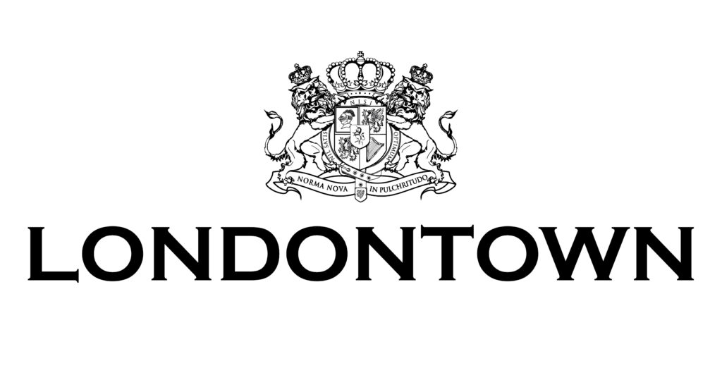

LondonTown USA is a women-owned, family-run business based in the U.S.—even though their story started across the pond.
They create products that are free of all the things you don’t want, and full of the things you do and formulas that leave nails and skin looking lustrous, healthy, and better than before. LondonTown promises to deliver forward thinking formulas with unparalleled results using carefully curated clean ingredients that you never have to question. During the 1940’s two sisters were separated: Marina Dimentman’s grandmother stayed behind while her great-aunt moved hundreds of miles away to England, unsure if they would ever see each other again. Letters became their lifeline, but these were no ordinary notes: messages from Radlett, England were laced with beautiful botanicals handpicked from the family garden.
Wartime rationing had left them bereft of any luxury, much less basic
beauty essentials–so the two sisters concocted their own. Out of these flower oils and herbal extracts came restorative recipes, all designed to pamper and treat. Three generations later, while working as a patent attorney and pregnant with her first child, Marina Dimentman was reminded of those cherished family remedies. Frustrated by the lack of effective nail care for women who needed safe alternatives-expecting or not. She was determined to create a solution that didn’t require a choice between holistic nail color and care that worked. Her grandmother’s antioxidant-enriched, flower oil emulsion was the answer. And with it, Londontown was born. That original remedy would become known as Florium Complex: the heart of Londontown and inspiration behind every formulation we make. Marina Dimentman is proud that they’ve set the bar in clean nail color and care thus far. But it’s not enough to just be clean, they are vigilantly
forging ahead pushing the boundaries of innovation.

LondonTown USA is made in New York, New York
Check them out at: https://www.londontownusa.com/

The best way to make positive change in the world of woke businesses is to vote with your wallet, so remember shop local, shop the highest score possible, and shop American! 2ndVote is not paid for this feature.

Links in this article:
- https://www.2ndvote.com/business-entity/londontown-usa/
- https://www.londontownusa.com/

